**Test Results**

1. Find a store with a given USA zipcode.

URL: [http://localhost:8080/CauseCode-Assignment/rest/store/findStore/{zipcode_id}](http://localhost:8080/CauseCode-Assignment/rest/store/findStore/%7bzipcode_id%7d)

Method Type: POST

Request: PathParam{} only

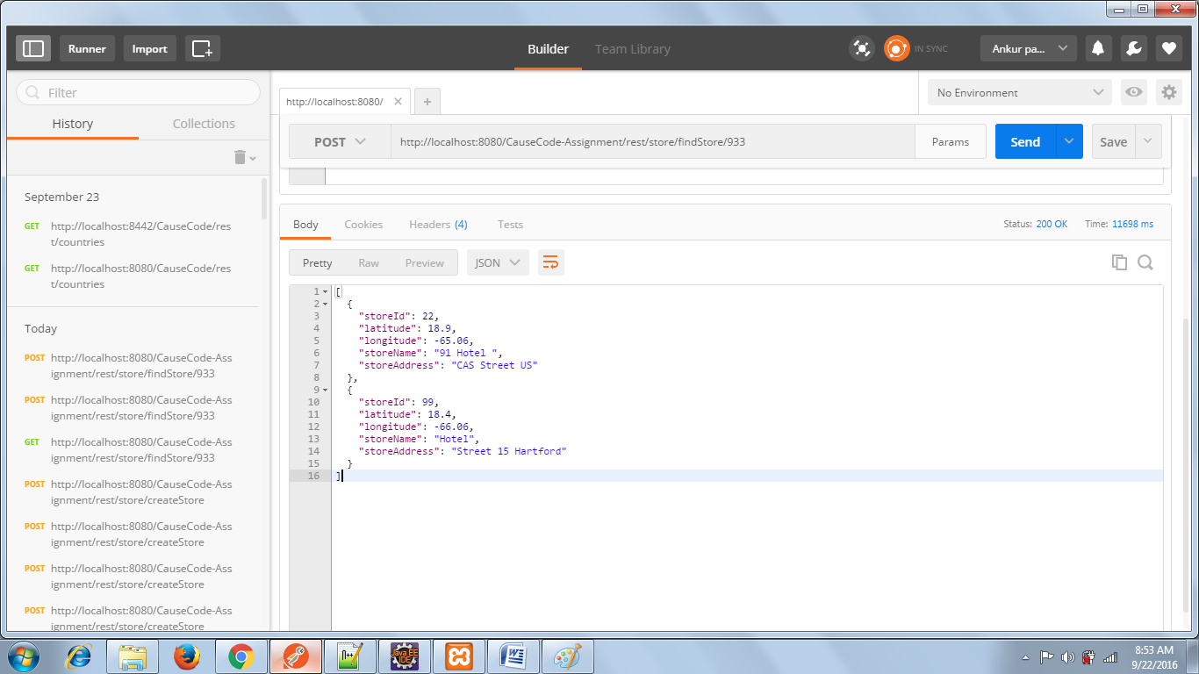

1. Create a new store

URL: <http://localhost:8080/CauseCode-Assignment/rest/store/createStore>

Method Type: POST

Request: {

"storeId": 99,

"latitude": 18.4,

"longitude": -66.06,

"storeName": "Hotel",

"storeAddress": "Street 15 Hartford",

"zipcode":{

"zipcode_id" : 933

}

}

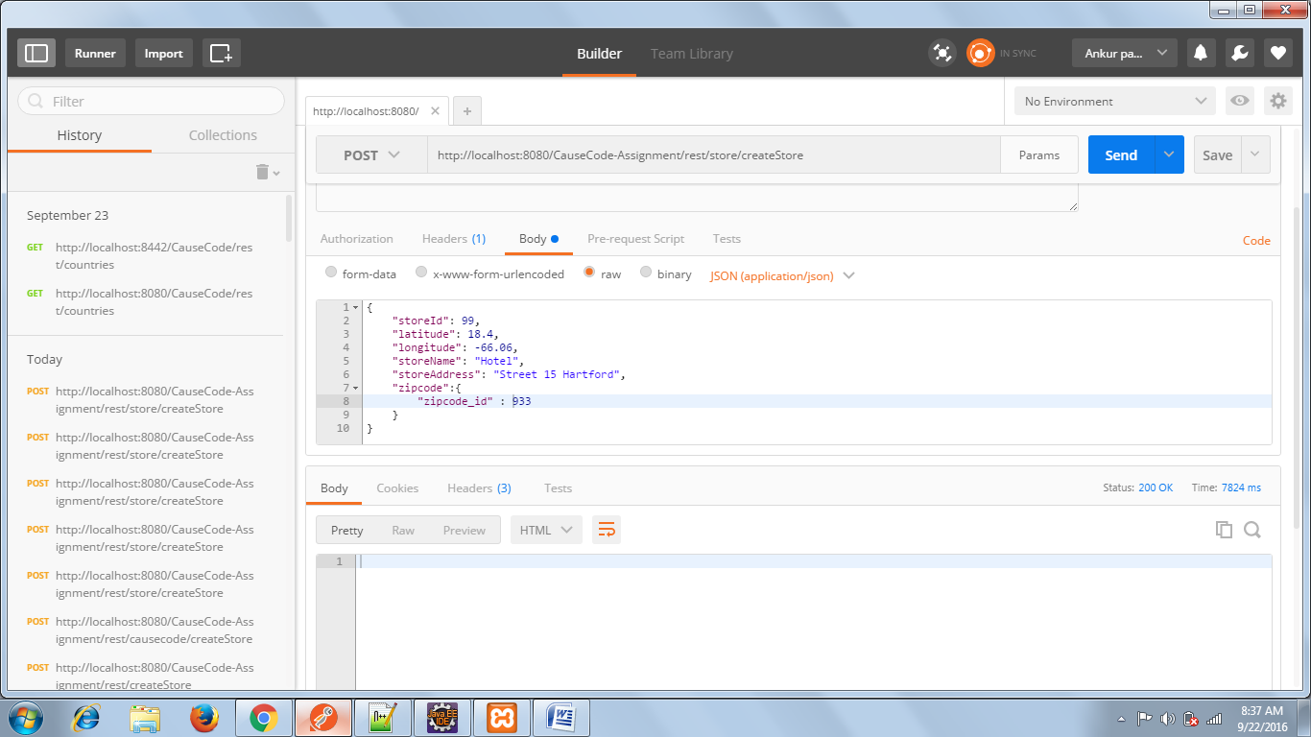

1. Update an existing store

URL: [http://localhost:8080/CauseCode-Assignment/rest/store/updateStore{storeId}](http://localhost:8080/CauseCode-Assignment/rest/store/updateStore%7bstoreId%7d)

Method Type: PUT

Request: {

"storeName": "Hotel",

"storeAddress": "Street 15 Hartford"

}

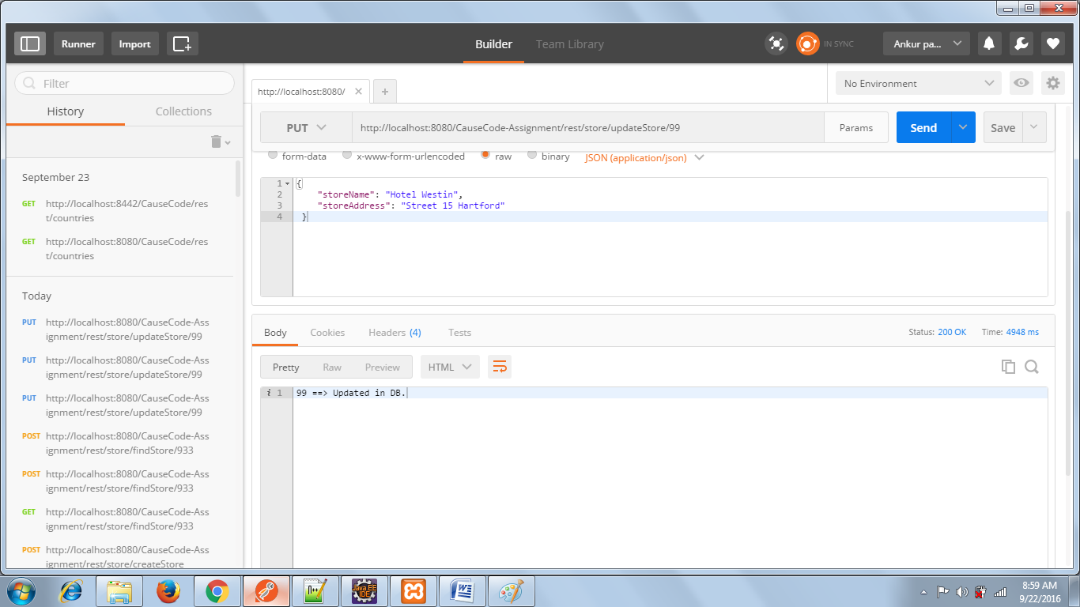

1. Delete an existing store

URL: [http://localhost:8080/CauseCode-Assignment/rest/store/deleteStore{storeId}](http://localhost:8080/CauseCode-Assignment/rest/store/deleteStore%7bstoreId%7d)

Method Type: DELETE

Request: NONE

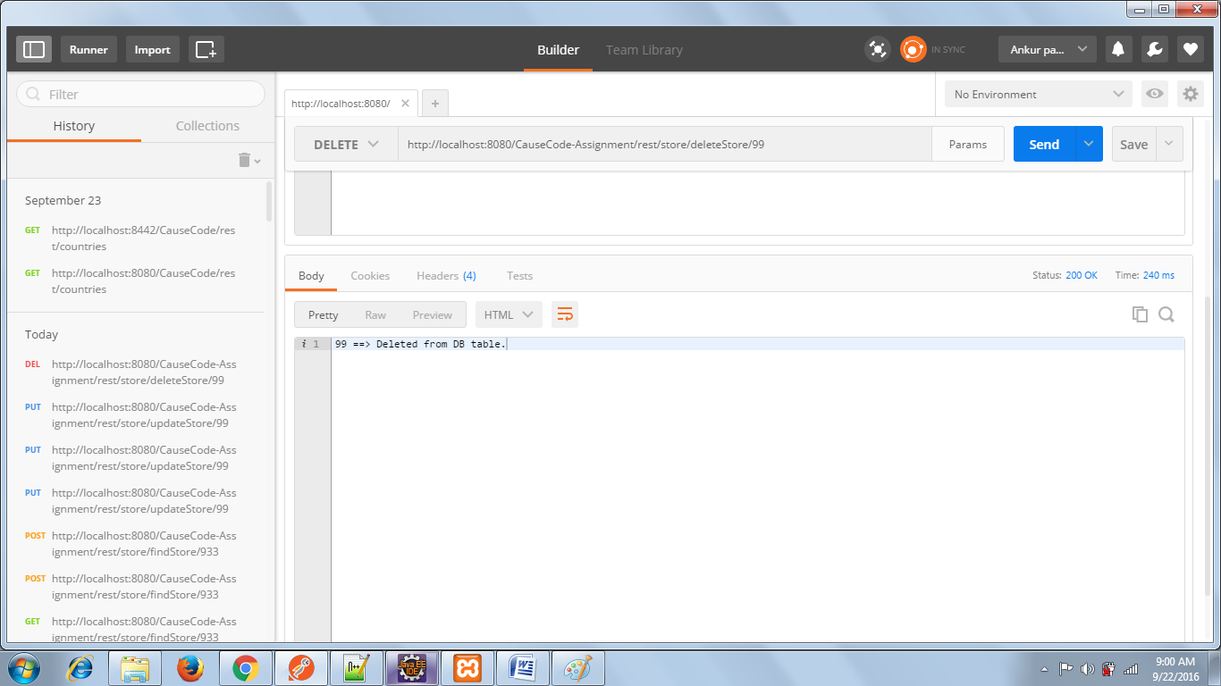

1. Get Zipcode data

URL: <http://localhost:8080/CauseCode-Assignment/rest/zipcode/getZipcode>

Method Type: GET

Request: NONE

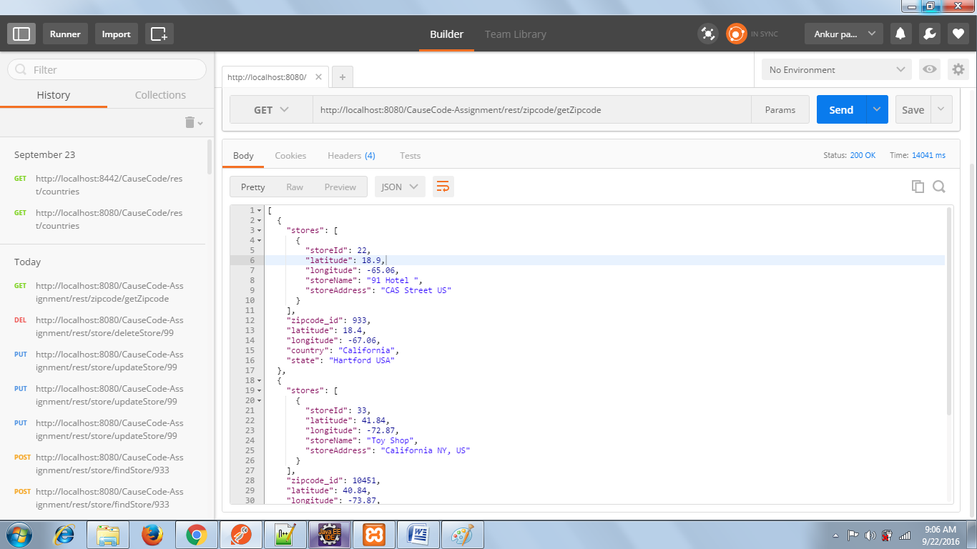

1. Create new Zipcode location

URL: <http://localhost:8080/CauseCode-Assignment/rest/zipcode/createZipcode>

Method Type: POST

Request: {

"zipcode_id": 411028,

"latitude": 18.4,

"longitude": -66.06,

"country": "US",

"state": "Hartford"

}

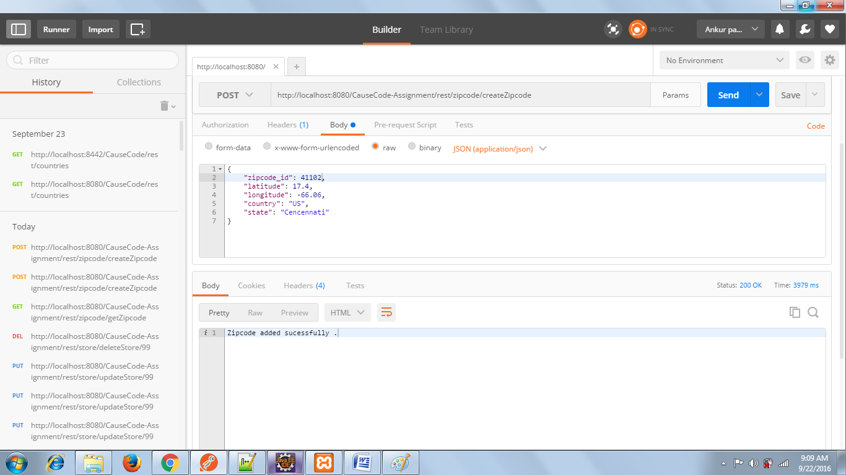

1. Update an existing Zipcode location

URL:[http://localhost:8080/CauseCodeAssignment/rest/zipcode/updateZipcode/{zipcode_id}](http://localhost:8080/CauseCodeAssignment/rest/zipcode/updateZipcode/%7bzipcode_id%7d) Method Type: PUT

Request: {

"country": "US",

"state": "Hartford"

}

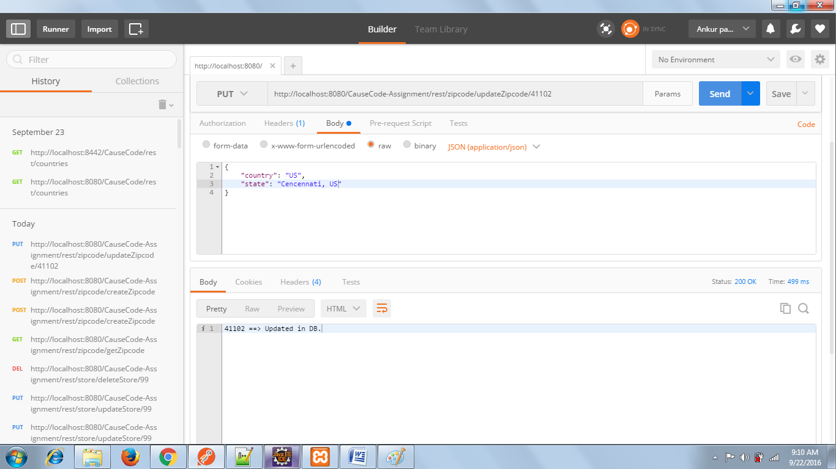

1. Delete an existing Zipcode location

URL:[http://localhost:8080/CauseCodeAssignment/rest/zipcode/deleteZipcode/{zipcode_id}](http://localhost:8080/CauseCodeAssignment/rest/zipcode/deleteZipcode/%7bzipcode_id%7d) Method Type: DELETE

Request: NONE

